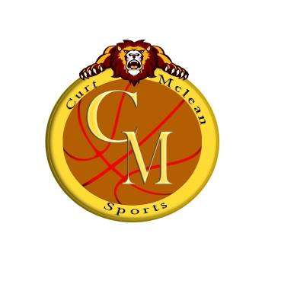
Dear Coach,
Good afternoon and thank you for expressing your interest in our event.CM Sports and its partners Hoops Canada and Brampton Minor Basketball is extending this personal invitation to you and your teams and club(s) to participate in our 1st Toronto International Basketball Tournament in Toronto, Canada which will take place on July 19th thru 28th 2015 in Brampton, Ontario Canada. (NCAA CERITICATION IN PROCESS)
The tournament that we have planned for the summer will be like no other that you have been engaged in. We at CM Sports think basketball is the key component for the development and discipline of these kids and will help them with their journey through life. As we continue to emphasize; fair play, friendships, health& wellness, good sportsmanship, team building and family participation.

The benefits of this International Tournament in Toronto is to promote integration, interaction, tourism and culture exchange also bringing different countries together, respecting diversity and allow players and coaches bond closer together which greatly enhancing unity. You will also have the chance to go watch other basketball games at the Pan America games which is also in Toronto that same time period.

This will be a pool play format tournament with awards to the top (3) teams in each division.
We hope that you and your team (s) will take this opportunity to come and enjoy the charm and beauty of the Toronto International Showcase and play some great games. I ask that you think about the kids and the opportunity they will get if they win and not the cost of tournament.

Date: July 19th thru July 28th, 2015

Location: Brampton, Ontario (Gyms are located just north of the city of Toronto)

Entry Deadline: July 10th, 2015

Entry Fee: $550 BEFORE June 20^{TH $}650 AFTER (4 Games Guaranteed)

Divisions: U14, U15, U16, U17, U18/ U19 Boys /Girls (8 Teams per Division)

Yours Truly,

Curt McLean, President
CM Sport Tours

