The Women's Basketball Camp (WBC) will be held at the Shantel Hardison Sports Center in the city of Shreveport, LA on Saturday and Sunday, August 9-10th

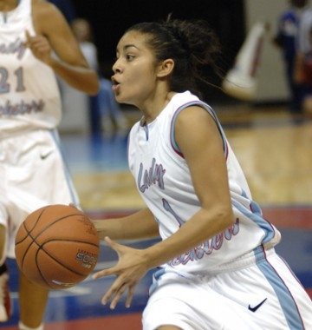2014 Women's Basketball Camp

Come join us for the 2014 Women's Basketball Camp – the premier women's basketball camp for
women basketball players (18 yrs or older) seeking to take their game to the next professional level. Representatives from some of the top women's basketball leagues and agents will be present, ready to sign top talent.

Some of the leagues represented at the Women's Basketball Camp include:
WNBA (Women's National Basketball Association)
WABA (Women's American Basketball Association)
WUBA (Women's Universal Basketball Association)
WBCBL (Women's Blue Chip Basketball League)
LNBPF (Liga Nacional de Baloncesto Profesional Femenil​)

The Shantel Hardison Gymnasium is the official home of the
2014 WBC​, right here in the Shreveport, LA! (official website​)

Where: Shantel Hardison Sports Center, 2642 Youree Drive/East Washington, Shreveport, LA​
When: Saturday and Sunday, ​​August​ 9-10th, 2014​​
Time: 9am - 5pm (Both Days)
Airport To Travel Into: Shreveport Downtown Airport​​, 1550 Airport Dr. Shreveport, LA​
Recommended Hotel Accommodations: Days Inn Bossier City, 200 John Wesley Blvd, Bossier City, LA 71112
Recommended Ground Transportation: www.supershuttle.com​

​Camp Schedule: Saturday, August 9th – 9AM – 5PM – Drills/Games
Sunday, August 10th – 9AM – 2PM – Drills/Games

Camp Directors: LaQuan Stallworth (bio​)
Shantel Hardison​ (bio​)

Who Will Be There: Basketball Coaches, Scouts, Sports Agents and Team Representatives from different women's basketball leagues from across the United States and overseas listed! They will be prepared to sign talented players, so get ready and register NOW!

How Do I Register: You can online register on our site at: www.womensbasketcamp.eventbrite.com​ or click on the link below.

Registration Fee: $150 before Friday, August 1, 2014
$225 after Friday, August 1, 2014. Late/Walk-In registration will be accepted also.

​
Other Info: NCAA/Pro experience is helpful, but not necessary. For more information, please email us at: info@womensbasketcamp.com

There is no other opportunity in the U.S. like the 2014 Women's Basketball Camp!
- ​Representatives from major women's basketball leagues present!
- Direct exposure to Owners, Coaches, Scouts, Agents and Team Representatives!
- Teams and Agents are prepared to sign players at the event!
- Multiple Basketball Courts for individual skill workouts and continuous play!
- Live video feeds to youtube, livestream, ustream and vimeo!
Register NOW….space is limited to 60 players!

​

