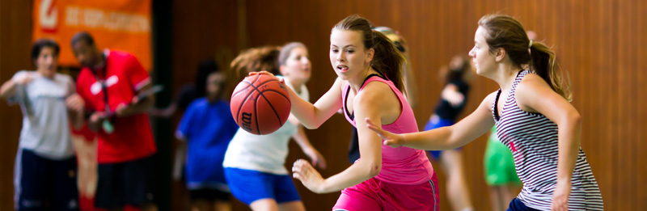

http://www.swissbasketballcamp.com/

- HOME
- CAMP
- STAFF 2014
- REGISTRATION
- CONTACT
- SPONSORS
- HOTELS
- FACEBOOK
- HALL OF FAME

EUROPE'S BIGGEST BASKETBALL CAMP
FOR BOYS AND GIRLS FROM 8 TO 19 YEARS
- Camp: July 13th 2015-July 18th 2015
2. Camp: July 20th 2015 - July 25th 2015
in Zofingen, Switzerland
The place to be!
It's not just a Camp, it's a happening!

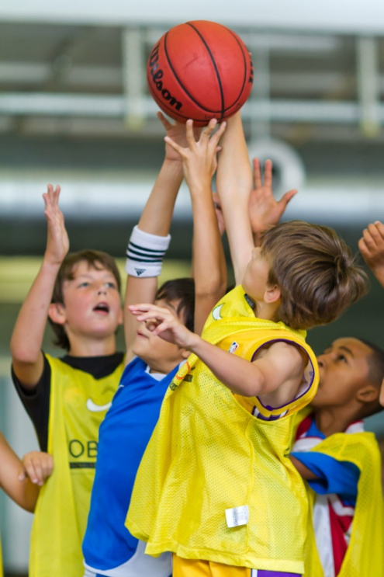 | 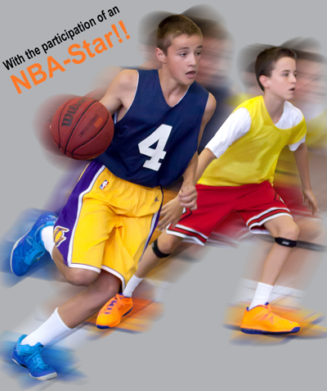

designed by thunermeer webdesign
2014

