EXCLUSIVE BASKETBALL TOURNAMENT
BASKETBALL TOURNAMENT
- Home
- About Us
- Application
- Tournament Rules
- General Information
- Basketball Camp
- Main Prize
- Basketball Camp
- Nowa strona
Basketball Agency "ILYB"
Poland e-mail:
basketpromotion@wp.pl
Serbia email:
lakaconi@gmail.com

Phone Poland :
0048 796 06 27 22
Phone Serbia:
00381 652 066 066

www.ilyb.bnx.pl
www.ilyv.dbv.pl

www.
basketcamp.jimdo.com

www.basketcamp.
wix.com/serbian

BASKETBALL TOURNAMENT
EXCLUSIV INTERNATIONAL
BASKETBALL TOURNAMENT

First prize in the tournament for coach of the
winning team is : NEW CAR
(or the equivalent of a car in cash -euro)

DATE TOURNAMENT: 01-04 may 2014
Place: BYDGOSZCZ/ POLAND
For: BOYS born: 1998/1999
Cost:
-entry fee for participating in the tournament: 80 euro;
accommodation from Thursday:
-90 euro per person (accommodation 01-04.05.2014) Youth Hostel-meals from lunch thursday to lunch Sunday
-115 euro per person (accomodation 01-04.05.2014 Hotel *** "Best Inn" , meals from lunch on Thursday to lunch on Sunday)
accommodation from Wednesday:
-115 euro per person (accommodation 30-04.05.2014) Youth Hostel-meals from lunch thursday to lunch Sunday
-145 euro per person (accomodation 30-04.05.2014 Hotel *** "Best Inn" , meals from lunch onWednesday to lunch on Sunday)

First game each team will play on 01/05/2014.
4 groups (5 teams in the group)
Each team will play 4-6 games.
The team conducted shootout for three points.
Every coach and player will receive a commemorative T-shirt (gratis)
Awards:
1 place -NEW CAR FOR COACH and Cup, medals and
prizes for the coach and players.
2 place -200 euro for coach and Cup, medals and
prizes for the coach and players
3 place -100 euro for coach nad Cup, medals and
prizes for the coach and players.
In each group will be awarded (statuettes and prizes): Tournament MVP, best center, the best shooter for the three points, the best playmaker, best Scorer player in the tournament.
Applications are accepted until 30.03.2014.
The payment of the entry fee: 60 euro must be paid by 30.03.2014 at our bank account:
NAME OF BANK -Citi Bank Poland
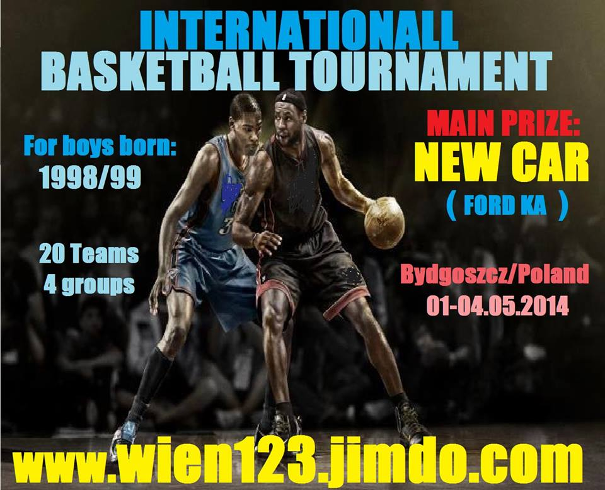

Video: http://www.youtube.com/watch?v=kXgEoQviIBw

account number :
PL 31 1030 0022 4802 0396 8201 1156

Stopka | Wersja do druku | Mapa strony
Zaloguj
Jimdo
Podoba Ci się ta strona? Stwórz własną bezpłatną witrynę! Zarejestruj się nawww.jimdo.pl.

